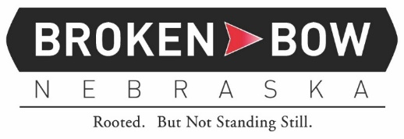

NOTICE OF SPECIAL MEETING
CITY OF BROKEN BOW, NEBRASKA

NOTICE IS HEAREBY GIVEN, that a Special Meeting of the Mayor and Council of the City of Broken Bow, Nebraska will be held at 12:00 P.M. on Tuesday, March 7, 2023, in the Broken Bow Municipal Auditorium, 314 South 10th Avenue, Broken Bow, Nebraska, which meeting will be open to the public. The agenda for such meeting is kept continuously current and is available for inspection at the City Clerk’s office. Items on the agenda are:

- Ratification of Termination of Daniel Knoell’s Contract and Release.

/s/ Kandi K. Peters
City Clerk

